**TP MODUL 7**

NAMA : Ahmad Naufal Ramadhan  
NIM : 103012300239  
KELAS : IF-47-02

header.h

main.cpp

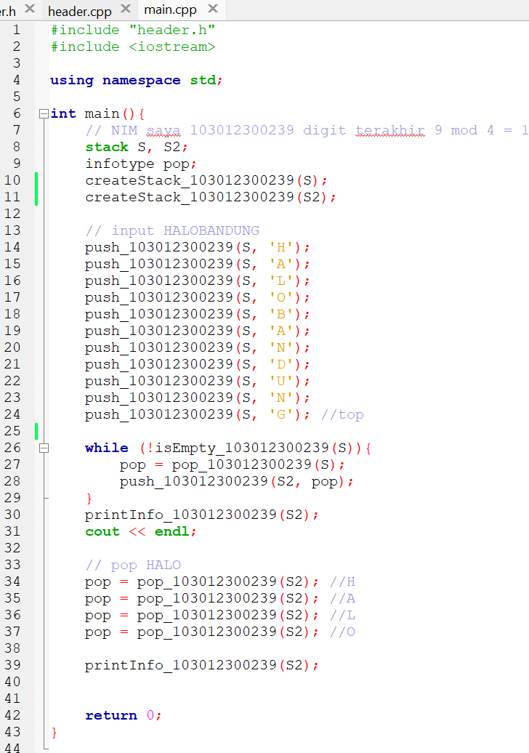

Running

